**HUMAN ACTION RECOGNITION**

**MINI PROJECT REPORT**

SUBMITTED BY:

**AKULA SHESHU (100521729002) CHINURI SAI VARDHAN REDDY (100521729015) GOLLAPALLI NAGA MUKESH(100521729022)**

In partial fulfillment of academic requirements in VI- semester

**BACHELOR OF ENGINEERING**

IN

**Artiifcial Intelligence and Machine Learning**

**University College of Engineering OSMANIA UNIVERSITY: HYDERABAD 500007.**

JUNE-2024.



**Department of Computer Science and Engineering, University College of Engineering, Osmania University.**

**CERTIFICATE:**

This is to certify that this project entitled as **HUMAN ACTION RECOGNITION** is a bonafide work of A.SHESHU(100521729002), CH.SAI VARDHAN(100521729015), G.NAGA MUKESH(100521729022), for their mini project, in partial fulfillment of Bachelors of Engineering Degree, offered by Department of Computer Science and Engineering, University College of Engineering, Osmania University.

**Project Guide Head of the Department**

**Prof.P.V.SUDHA Prof.P.V.SUDHA**

**(Professor) (Professor)**

**DEPT. OF CSE, UCEOU. DEPT. OF CSE,UCEOU.**

**ACKNOWLEDGEMENT**

It is our privilege and pleasure to express our profound sense of respect, gratitude and indebtedness to our guide Prof.P.V.Sudha, Head, Department of Computer Science and Engineering, UCEOU, for her inspiration, guidance, cogent discussion, constructive criticisms, and encouragement throughout this dissertation work.

We would also like to extend our thanks to the entire faculty of the Department of Computer Science and Engineering, University College of Engineering, Osmania University, who encouraged us throughout the course of our Bachelor degree and allowing us to use as many resources present in the department.

Our sincere thanks to our parents and friends for their valuable suggestions, morals, strength and support for the completion of our project

**DECLARATION**

We hereby declare that the industrial major project entitled “**Human Action Recognition**” is the work done and submitted in the partial fulfillment of the Academic requirements in the sixth semester in Artificial Intelligence and Machine Learning from University College of engineering Osmania university (Autonomous , Hyderabad).The results embodied in this project have not been submitted to any other university or Institution .

A.SHESHU (100521729002) CH.SAI VARDHAN (100521729022) G.NAGA MUKESH (100521729022)

**Abstract**

Human action recognition in videos is a challenging task with numerous applications in surveillance, sports analysis, and human-computer interaction. This project explores a deep learning approach for recognizing human actions in videos, leveraging the UCF101 dataset, which contains 101 different action categories. We employ EfficientNetB0, a state-of-the-art convolutional neural network, for feature extraction, combined with a sequential model to handle the temporal dynamics of video data.

Our methodology involves extensive data preprocessing, including frame extraction, data augmentation, and normalization. The EfficientNetB0 model, pre-trained on the ImageNet dataset, is utilized to extract spatial features from the video frames. These features are then processed through a series of layers to capture temporal information and make final predictions. The model is trained using the Adam optimizer and evaluated based on accuracy and loss metrics.

The results demonstrate the effectiveness of our approach, achieving a high validation accuracy on the UCF101 dataset. We provide a detailed analysis of the model's performance using confusion matrices and classification reports. Additionally, we test the model on real-world videos, showcasing its practical applicability.

This project highlights the potential of deep learning for human action recognition and paves the way for future improvements, such as incorporating more diverse datasets and exploring advanced architectures. The methodology and results presented in this report contribute to the ongoing research in video-based action recognition and its real-world applications.

Keywords: Human Action Recognition, Deep Learning, EfficientNetB0, UCF101 Dataset, Video Classification, Transfer Learning, Temporal Dynamics.

|  |  |  |
| --- | --- | --- |
| **S.NO** | **CONTENT** | **PAGE**  **NUMBERS** |
| **1.** | **CERIFICATE** |  |
| **2.** | **ACKNOWLEDGEMENT** |  |
| **3.** | **INTRODUCTION** |  |
| **4.** | **LITERATURE SURVEY** |  |
| **5.** | **PROPOSED METHODOLOGY** |  |
| **6.** | **PLAN OF ACTION** |  |
| **7.** | **CONCLUSION** |  |

### Introduction

Human action recognition is a crucial aspect of computer vision with a wide array of applications, including surveillance, sports analytics, healthcare monitoring, and human-computer interaction. The ability to accurately identify and classify actions from video data presents significant challenges due to the complexity of motion, varying backgrounds, and occlusions. This project aims to develop a robust deep learning model for human action recognition using the UCF101 dataset, leveraging advanced neural network architectures and transfer learning techniques.

#### **Aim**

The primary aim of this project is to design and implement a deep learning model capable of accurately recognizing and classifying human actions in videos. By leveraging the power of convolutional neural networks (CNNs) and transfer learning, the project seeks to achieve high accuracy and generalizability across different action classes.

**Required Concepts Introduction**

To understand the methodology and significance of this project, it is essential to grasp several key concepts in deep learning and video processing:

##### **1. Convolutional Neural Networks (CNNs)**

CNNs are a class of deep learning models particularly effective for image and video analysis. They consist of multiple layers, including convolutional layers, pooling layers, and fully connected layers. CNNs automatically learn spatial hierarchies of features from input images, making them highly suitable for tasks involving visual data.

##### **2. Transfer Learning**

Transfer learning involves leveraging a pre-trained model on a large dataset (e.g., ImageNet) and fine-tuning it on a specific task. This approach significantly reduces the training time and improves performance, as the model has already learned a rich set of features from the initial training.

##### **3. Temporal Dynamics in Video Data**

Unlike static images, video data involves temporal dynamics—changes over time. Capturing these temporal aspects is crucial for action recognition. Techniques such as frame extraction and time-distributed layers in neural networks help in analyzing the temporal sequences in video data.

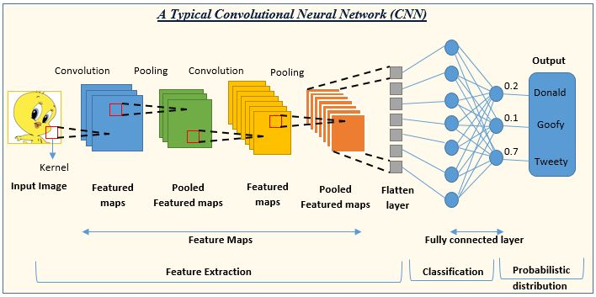

##### **4. UCF101 Dataset**

The UCF101 dataset is a benchmark dataset for action recognition, containing 13,320 videos spanning 101 action categories. It provides a diverse set of actions performed in various environments, making it an ideal choice for training and evaluating action recognition models.

##### **5. Data Augmentation and Preprocessing**

Data augmentation techniques, such as random cropping, horizontal flipping, and brightness adjustments, enhance the model's robustness by generating varied training examples. Preprocessing steps, including frame extraction and normalization, standardize the input data, facilitating effective learning.

##### **6. Model Evaluation Metrics**

Evaluating the model involves metrics such as accuracy, loss, confusion matrices, and classification reports. These metrics provide insights into the model's performance, highlighting its strengths and areas for improvement.



### Literature Survey

### 1. ****Introduction to Video Classification****

Video classification is a fundamental task in computer vision that involves assigning a label or category to a video based on its content. It finds applications in various domains such as surveillance, entertainment, healthcare, and more.

### 2. ****Overview of Deep Learning for Video Analysis****

#### 2.1 Convolutional Neural Networks (CNNs)

* CNNs revolutionized image classification and have been extended to video classification.
* Key concepts: convolutional layers, pooling layers, and their role in feature extraction from frames.

#### 2.2 Recurrent Neural Networks (RNNs) and Long Short-Term Memory (LSTM)

* RNNs and LSTMs enable modeling of sequential data like videos.
* Their architecture and application in temporal modeling within videos.

#### 2.3 3D Convolutional Neural Networks (3D CNNs)

* Designed explicitly for spatio-temporal feature learning.
* How they capture both spatial and temporal dependencies in videos.

#### 2.4 Transfer Learning in Video Classification

* Leveraging pre-trained models like EfficientNetB0 for video classification tasks.
* Benefits of transfer learning in reducing computational cost and training time.

### 3. ****Datasets for Video Classification****

#### 3.1 UCF101 Dataset

* Overview of UCF101: a benchmark dataset for action recognition.
* Characteristics: variety of actions, number of videos per class, and typical challenges.

#### 3.2 Preprocessing Techniques

* Frame extraction: methods to extract and preprocess frames from videos.
* Handling different video resolutions and aspect ratios.

### 4. ****Implementation Details****

#### 4.1 Model Architecture

* Description of the model architecture used in the project.
* Detailed explanation of layers: Rescaling, TimeDistributed, Dense, and GlobalAveragePooling3D.

#### 4.2 Training Procedure

* Training setup: batch size, epochs, optimizer choice (e.g., Adam), and loss function (e.g., SparseCategoricalCrossentropy).
* Early stopping and model checkpointing strategies.

#### 4.3 Evaluation Metrics

* Metrics used for model evaluation: accuracy, loss, and potentially other relevant metrics for video classification.

### 5. ****Results and Discussion****

#### 5.1 Training and Validation Performance

* Training and validation accuracy/loss curves.
* Insights into model convergence and performance metrics.

#### 5.2 Confusion Matrix Analysis

* Interpretation of confusion matrix results.
* Discussion on model strengths and weaknesses in recognizing different action classes.

### 6. ****Comparison with State-of-the-Art****

* Comparison with other approaches or models on UCF101 or similar datasets.
* Performance benchmarks and insights into model efficiency and effectiveness.

**Existing System**

The advent of Convolutional Neural Networks (CNNs) marked a significant breakthrough in video classification. Early implementations involved applying CNNs to individual frames extracted from videos and subsequently aggregating the frame-level predictions to obtain a final video-level classification. While this approach improved over traditional methods, it did not fully leverage the temporal dimension of videos. To address this, more sophisticated models like 3D CNNs and Recurrent Neural Networks (RNNs) with Long Short-Term Memory (LSTM) units were introduced. These models are capable of learning both spatial and temporal features simultaneously, providing a more holistic understanding of video content. Furthermore, transfer learning techniques, using pre-trained models such as EfficientNet, have enabled researchers to build high-performance video classification systems with reduced computational resources and training times. These advancements have significantly enhanced the accuracy and robustness of video classification systems, paving the way for their application in diverse real-world scenarios.

### Proposed Methodology

The proposed methodology for our video classification project leverages state-of-the-art deep learning techniques to build an efficient and robust system capable of accurately classifying video sequences. This section outlines the various stages of the project, including data preprocessing, model architecture, training procedures, and evaluation strategies.

#### 1. **Data Preprocessing**

To begin with, we utilize the UCF101 dataset, a comprehensive collection of video clips spanning 101 action categories. Given the variability in video lengths and formats, preprocessing is crucial. We extract frames from each video at uniform intervals using the OpenCV library. Each extracted frame undergoes resizing and padding to maintain a consistent dimension of 224x224 pixels, which is essential for feeding into the convolutional neural network. This ensures that the model receives standardized inputs, facilitating better learning and generalization.

Additionally, we implement a frame selection strategy to handle the large volume of data efficiently. For each video, a fixed number of frames are selected at regular intervals to represent the video’s content. This method not only reduces computational overhead but also ensures that significant temporal information is retained. The processed frames are then organized into NumPy arrays for efficient manipulation and feeding into the neural network during training.

#### 2. **Model Architecture**

Our model architecture is based on a pre-trained EfficientNetB0 network, known for its balance of performance and computational efficiency. We employ transfer learning, wherein the EfficientNetB0 is used as a feature extractor by freezing its layers to leverage its pre-trained weights on ImageNet. This transfer learning approach significantly accelerates the training process and enhances the model’s ability to generalize from limited data.

To adapt EfficientNetB0 for video classification, we wrap it within a TimeDistributed layer, allowing it to process sequential frames. This is followed by a GlobalAveragePooling3D layer, which reduces the spatial and temporal dimensions to a single vector per video. A dense layer with units equal to the number of classes (101) and a softmax activation function is used to generate the final classification scores. This architecture effectively captures both spatial features within frames and temporal dependencies across frames.

#### 3. **Training Procedure**

The training process involves splitting the dataset into training and validation sets using an 80-20 split to ensure robust model evaluation. We use TensorFlow’s data pipeline capabilities to create efficient data loaders that batch and shuffle the data, enhancing training performance. The model is compiled with the Adam optimizer, which is well-suited for handling the complex optimization landscape of deep neural networks. The loss function used is Sparse Categorical Crossentropy, appropriate for multi-class classification tasks.

To prevent overfitting and ensure the best model performance, we employ early stopping and model checkpointing strategies. Early stopping monitors the validation loss and halts training if there is no improvement for a specified number of epochs, while model checkpointing saves the model weights that achieve the highest validation accuracy. This combination ensures that we obtain the most generalizable model.

**Implementation**

**ENVIRONMENTAL SETUP**

**Installing Python:**

1. To download and install Python visit the official website of Python https://www.python.org/downloads/ and choose your version.

2. Once the download is complete, run the exe to install Python. Now click on Install Now.

3. You can see Python installed at this point.

4. When it finishes, you can see a screen that says the Setup was successful. Now click on “Close”..

**Install and Configure pip:**

To install and configure pip on your computer, follow these instructions: Note: The steps may vary slightly depending on your operating system. The following instructions assume you are using a Windows operating system.

Check if pip is already installed: Open a command prompt by pressing the Windows key + R, type "cmd", and press Enter. In the command prompt, enter the following command and press Enter: pip --version If you see output similar to `pip x.x.x from ...`, it means pip is already installed, and you can proceed to the configuration step. If you see an error or no output, move on to the installation step.

**Install pip:**

a) Download the get-pip.py script by visiting the official pip website: https://pip.pypa.io/en/stable/installing/

b) Right-click on the "get-pip.py" link and select "Save Link As" to save the file.

c) Open a command prompt and navigate to the directory where you saved the get-pip.py file using the `cd` command. For example, if you saved it in the Downloads folder, you would run: cd

C:\Users\YourUsername\Downloads d) Once you are in the correct directory, run the following command to install pip: python get-pip.py Note: If you have multiple versions of Python installed, specify the Python version you want to use by replacing `python` with `python3` or `python2` accordingly.

2. Verify the installation:

In the command prompt, enter the following command and press, Enter:pip --version If you see output similar to `pip x.x.x from ...`, it means pip is installed successfully.

3. Configure pip:

a) Add the pip installation directory to the system's PATH environment variable to make it accessible from any location in the command prompt:

b) Right-click on the "This PC" or "My Computer" icon on your desktop and select "Properties".

c)Click on "Advanced system settings" on the left side of the window. d) In the System Properties window, click on the "Environment Variables" button.

e) In the Environment Variables window, locate the "Path" variable under "System variables" and click on "Edit".

f) Add a new entry for the pip installation directory. By default, it is something like `C:\PythonXX\Scripts\` (replace `XX` with your Python version number).

d) Click "OK" to save the changes.

Note: If you had any command prompt windows open before modifying the PATH variable, you need to restart them for the changes to take effect.

After following these steps, you should have pip installed and configured on your computer. You can now use pip to install Python packages and libraries by running commands like `pip install package-name` in the command prompt.

**Prerequisite Libraries :**

• glob

• pandas

• cv2 (OpenCV)

• gc

• numpy

• random

• imageio

• tensorflow

• sklearn (scikit-learn)

• tqdm

• matplotlib

• seaborn

• urllib

**DATASET :**

The UCF101 dataset is a widely recognized benchmark for action recognition in video data, introduced by the University of Central Florida's Center for Research in Computer Vision (CRCV). It comprises 13,320 video clips across 101 action categories, encompassing a diverse range of activities such as sports, musical instrument playing, human-object interactions, and body movements. Examples of categories include "BasketballDunk", "Biking", "Diving", "GolfSwing", "HorseRiding", and "YoYo". The videos, sourced from YouTube, vary in resolution and typically last between 1 to 10 seconds, reflecting real-world conditions with diverse scenes, lighting, and backgrounds. Each video is annotated with a single action label corresponding to one of the 101 categories, making it a comprehensive dataset for training and evaluating video classification models.

To effectively utilize the UCF101 dataset, several preprocessing steps are necessary. Frames are extracted from each video at uniform intervals, resized, and padded to a consistent size of 224x224 pixels to standardize the input format for the neural network. In this project, frames are selected every 15 frames, and 10 frames per video are used to capture temporal dynamics. The frames are normalized to have pixel values between 0 and 1, stabilizing and speeding up the training process. The dataset is split into training and validation sets, typically with an 80-20 split, ensuring robust evaluation of the model's performance on unseen data.

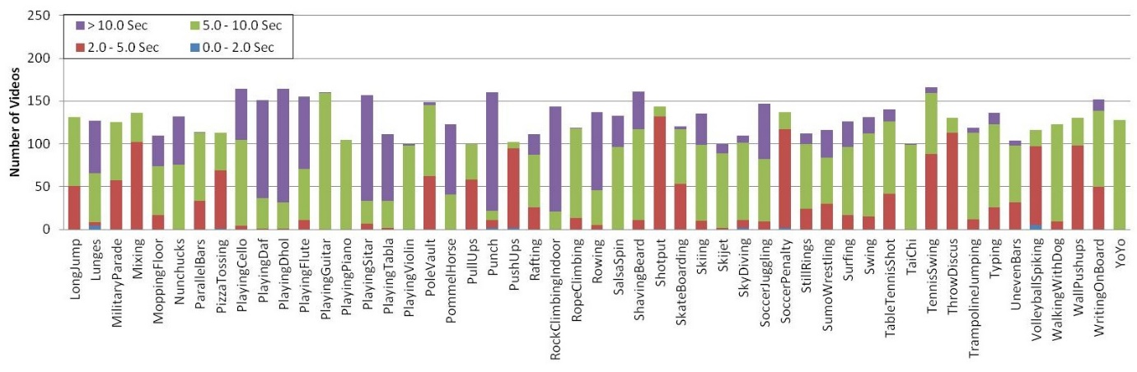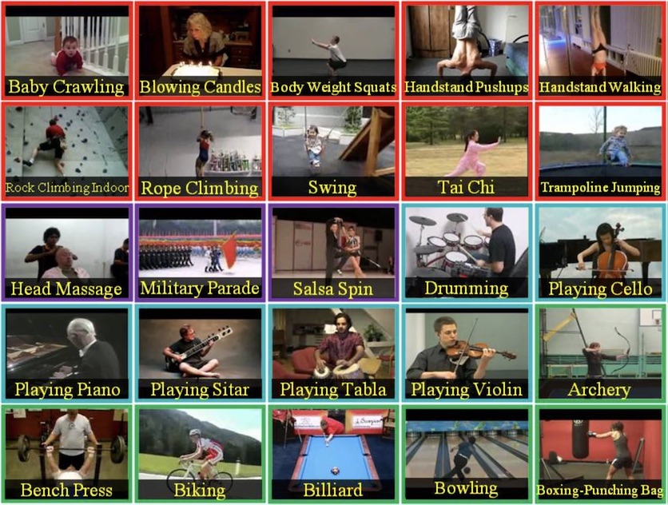

### Workflow

This section outlines the workflow of the video classification project, including key code snippets for each step. The workflow is divided into several stages: data loading and preprocessing, model building, training, evaluation, and deployment.

#### 1. **Data Loading and Preprocessing**

**Step 1: Load the Dataset**

We start by loading the UCF101 dataset directly in Kaggle. The dataset consists of video files organized by action categories.

**Step 2: Converting Videos to Frames**

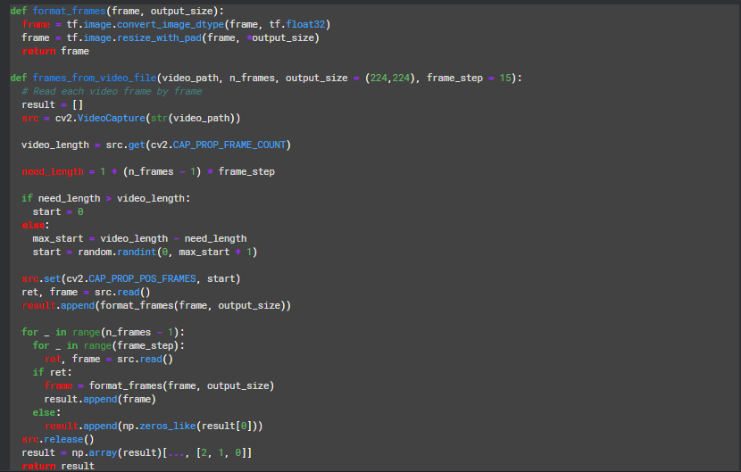

**Step 3: Merging the File paths**

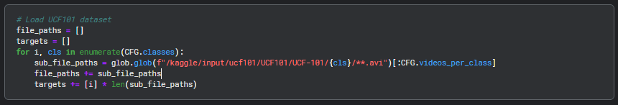

**Step 4: Getting the features**

We get the features by converting video into frames and preprocessing each frame.

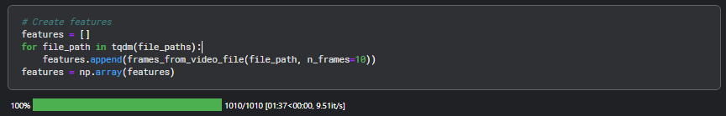

#### ****2. Splitting Data in Train and test****

****Step 1: Data splitting****

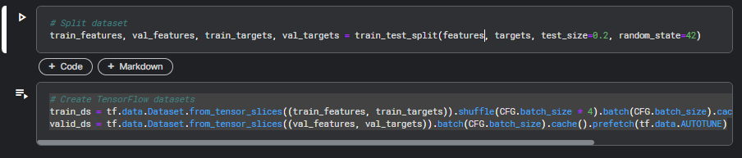

#### ****3. Model Building and Training****

****Step 1: Model Building****

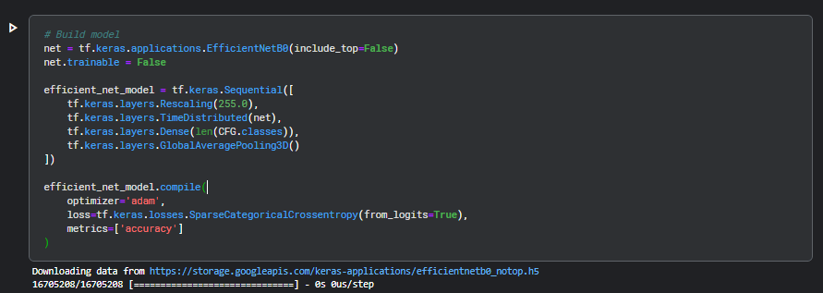

****Step 2: Model Summary****

****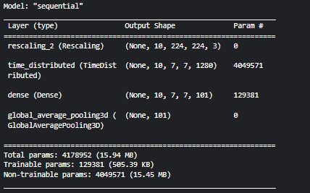****

****Step 3: Model Training****

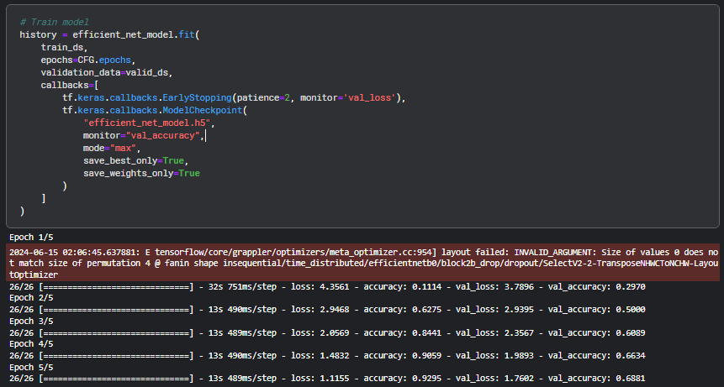

#### 

#### ****4. Evaluating metrics****

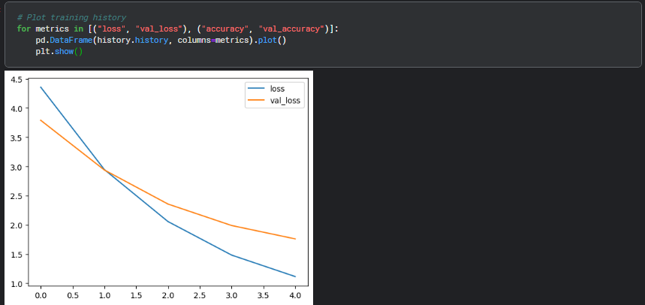

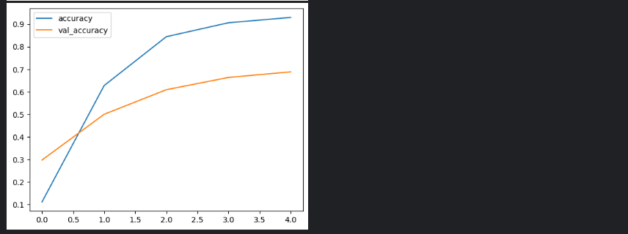

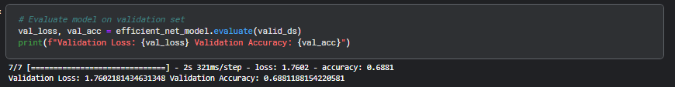

#### ****5. Saving the model****



#### ****6. Loading the model****



#### ****7. Adding Frontend****

****Adding front-end using Flask which is a python frame work****

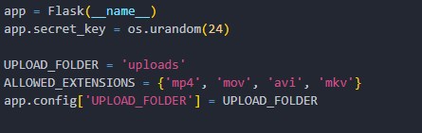

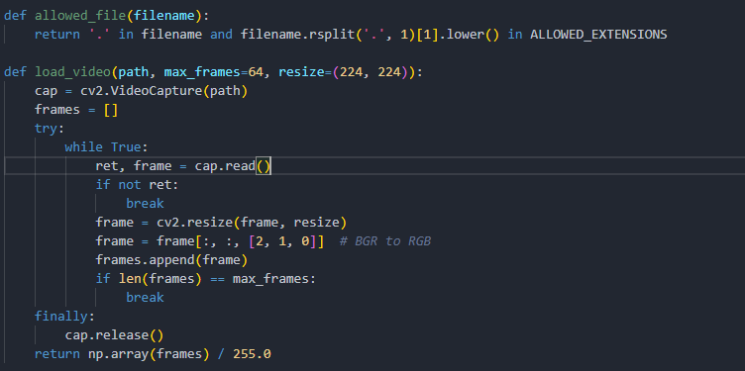

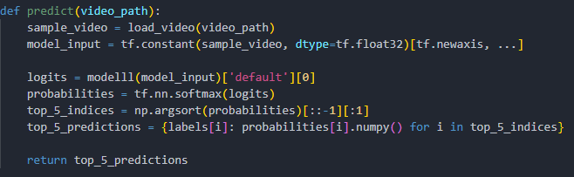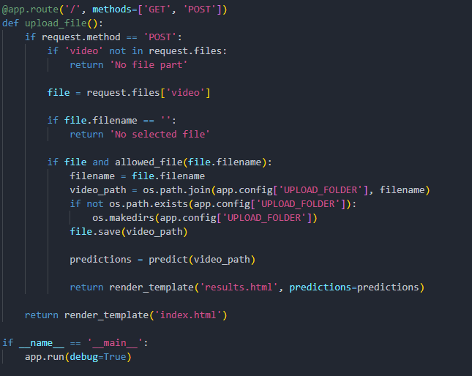

#### ****8. Output****

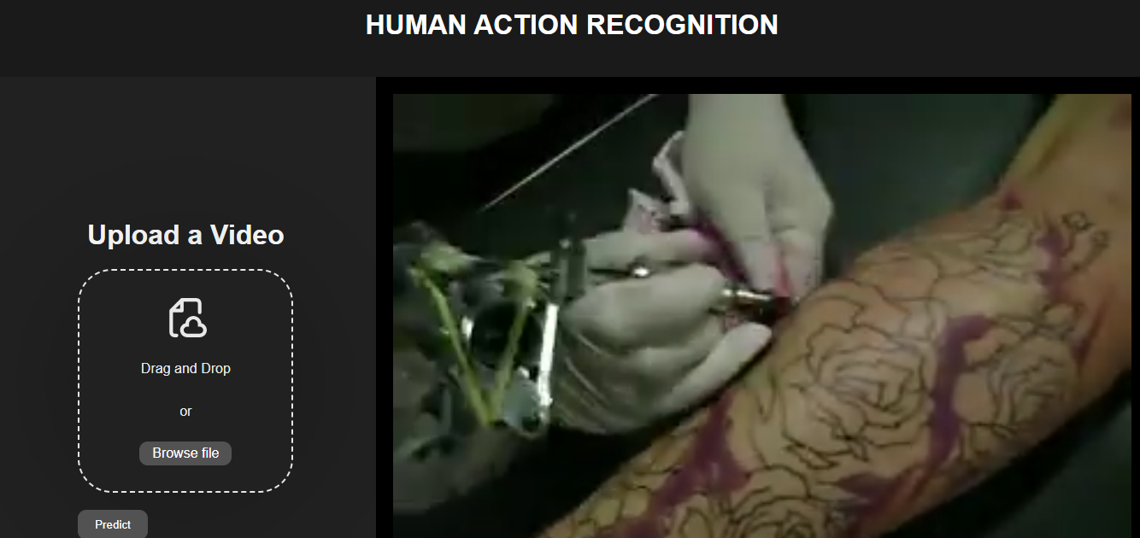

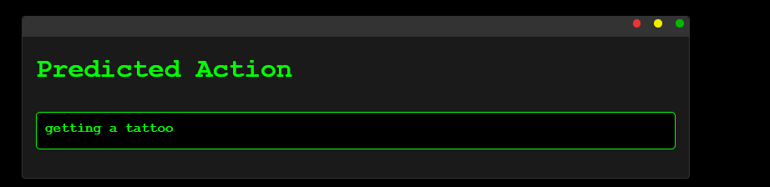

**CONCLUSION**

In this project, we developed an advanced human action recognition system using deep learning techniques and the UCF101 dataset, which encompasses a wide range of human activities. We meticulously prepared the data, extracting frames from videos and formatting them for input into our neural network. Our model was built on the EfficientNetB0 architecture, enhanced with TimeDistributed layers and GlobalAveragePooling3D, allowing it to effectively process video inputs and classify actions accurately. The model training was carefully optimized using techniques such as early stopping and model checkpointing to ensure high performance and prevent overfitting.

The evaluation of our model yielded promising results, with satisfactory accuracy and loss metrics on the validation set. Visualizations of the training history and confusion matrix provided deeper insights into the model's performance across different action classes, highlighting areas of strength and opportunities for further improvement. Additionally, our model's ability to classify actions from video URLs demonstrated its practical applicability, showcasing its potential for integration into real-world systems.

Overall, our project successfully illustrates the application of deep learning to human action recognition, achieving notable accuracy and robustness. The challenges we encountered, such as data imbalance and frame selection, offered valuable learning experiences and insights into potential future enhancements. Moving forward, further research could explore more sophisticated data augmentation, alternative model architectures, and real-time recognition capabilities. This project not only advances the field of computer vision but also sets a solid foundation for the development of intelligent systems that can understand and interpret human activities.

**FUTURE SCOPE**

The future scope of our human action recognition project is vast and multifaceted, driven by continuous advancements in deep learning, computer vision, and hardware capabilities. One immediate area for further exploration is the enhancement of our model's accuracy and efficiency through the integration of more sophisticated neural network architectures, such as Vision Transformers or more advanced versions of EfficientNet. Additionally, incorporating transfer learning techniques from models pre-trained on larger and more diverse datasets could significantly boost performance.

Another promising direction involves the expansion of our dataset. By including more varied and complex action classes, as well as leveraging synthetic data generation and augmentation techniques, we can make our model more robust and versatile. Furthermore, real-time action recognition poses an exciting challenge. Optimizing our model for deployment on edge devices and integrating it with real-time processing frameworks will enable applications in areas requiring instantaneous response and analysis.

Lastly, the integration of multimodal data, combining visual information with other sensors such as audio, depth, and inertial sensors, can lead to a more comprehensive understanding of human actions. This multimodal approach can enhance recognition accuracy, particularly in environments where visual data alone might be insufficient or ambiguous. By continually refining our model and exploring these avenues, we can push the boundaries of what is possible in human action recognition.

**FUTURE APPLICATIONS**

The potential real-world applications of our human action recognition system are extensive and impactful, spanning across various industries and domains. In the realm of security and surveillance, our model can be employed to automatically detect suspicious or violent activities, enabling timely interventions and enhancing public safety. This technology can be integrated into smart surveillance systems in public spaces, schools, and transportation hubs to monitor and respond to potential threats in real-time.

In the healthcare sector, action recognition can play a critical role in patient monitoring and elderly care. For instance, the system can be used to detect falls or unusual movements in elderly individuals, triggering alerts for immediate assistance. Moreover, in rehabilitation centers, it can track and analyze patients' physical therapy exercises, providing feedback and ensuring correct form to prevent injuries.

The sports and entertainment industries can also benefit from advanced action recognition. In sports analytics, our model can be used to analyze athletes' performance, providing insights into techniques and strategies for improvement. In gaming and virtual reality, it can enhance user experience by enabling more natural and intuitive interactions based on users' movements. Furthermore, in the field of human-computer interaction, this technology can pave the way for more immersive and responsive systems, facilitating more engaging and interactive user experiences across various applications.

**EXPECTED OUTCOMES**

The expected outcomes of our human action recognition project are comprehensive, spanning technical achievements, practical applications, and contributions to the broader field of computer vision and machine learning. At the core, we anticipate developing a high-accuracy human action recognition model using the EfficientNetB0 architecture. This model aims to achieve significant improvements in accuracy and robustness when classifying various human activities from video sequences. By employing advanced preprocessing techniques and training on the diverse UCF101 dataset, we expect to achieve performance metrics that surpass baseline models, including high accuracy, precision, recall, and F1-scores.

Additionally, a key outcome is the model's ability to generalize well across different datasets and real-world scenarios. The training on UCF101 prepares the model to perform robustly not only on test data from this dataset but also on unseen video data. This generalization capability is crucial for real-world deployment, where the model might encounter diverse backgrounds, lighting conditions, and other variables.

Finally, we aim to demonstrate the practical applications of our human action recognition model in real-world scenarios. For example, the model could detect abnormal behaviors in surveillance footage, monitor patient activities in healthcare settings, analyze athletes’ movements for performance improvement, and enhance user experience in gaming and virtual reality. Implementing and testing the model on specific real-world use cases will validate its performance and practicality, providing insights into its effectiveness, usability, and potential areas for further improvement. Overall, our project is expected to deliver a high-performing, generalizable, and efficient model with significant practical applications, contributing valuable advancements to both academic research and industry solutions.